Module, UI Design & AI Integration

Part 1: Module Design
1. User/Authentication Module
Responsibilities
- Register new user
- Login user
- Store user profile information
Database Collections
- Users
(Explanation
This module handles user accounts. When someone creates an account or logs into the app this module checks their information and connects it to the database.(MongoDB))

2. Workout Module
Responsibilities
- Log workouts
- Keeps track of exercises, reps, and weights
- Calculate XP from workouts
- Update character stats
Database Collections
- Workouts
- Characters Updated Info
- Users
(Explanation
This module handles the workout logs. When a user logs a workout the system saves the exercise information like reps or weights used. Then it is used to give XP to the character.)

3. Hydration Module
Responsibilities
- Track water intake
- Shows hydration progress
Database Collections
- WaterLogs
- Users
(Explanation
This module tracks how much water they drink during the day. The Database (MongoDB) saves that information and shows their progress when checked.)

4. Battle/Game Module
Responsibilities
- Start battles
- Track battle results
- Reward XP and gold
Database Collections
- Battles
- Characters
- Users
(Explanation
This module controls the game part of the app. Users can enter battles and use their character to fight enemies. The character's level and strength comes from the workouts the user will log so the more active the user is, the stronger their character becomes.)

5. Dashboard Module
Responsibilities
- Show workout progress
- Show hydration progress
- Display character level and stats
- Display recent activity
Database Collections
- Workouts
- WaterLogs
- Characters
- Users
(Explanation
The dashboard is basically the main screen people will see. It shows a quick summary of the users activity like workouts, hydration progress and character stats.)

6. AI Recommendation Module
Responsibilities
- Analyzes workout history
- Suggest recommended workouts
- Suggest water intake amount
Database Collections
- Workouts
- WaterLogs
- Characters
(Explanation
This module uses AI to help users decide what workout they should do next. Looking at the persons previous workouts and activity history and suggests certain exercises that could help them improve as well as water intake for them).

Part 2: UI Design

1. Login Screen
Components
- Email input
- Password input
- Login button
- Register link
(Explanation
This allows the user to log into their account so they can access their workout data and character progress.)

2. Dashboard Screen
Components
- Character level display
- XP progress bar
- Workout summary
- Hydration progress
- Navigation menu
(Explanation
The dashboard shows the user their activity. It displays things like their level, workout progress and hydration status. This screen helps the user see how they are doing.)

3. Log Workout Screen
Components
- Exercise input
- Body part selection
- Reps input
- Weight input
- Submit button
(Explanation
This screen shows the user to enter details about the workout they completed. The information is inputted and the system records it and updates the users character progress.)

4. Water Tracker Screen
Components
- Water intake input
- Submit button
- Hydration progress display
(Explanation
This shows how much water the user drinks. The system tracks the amount and shows progress toward a daily hydration goal they have.)

5. Battle Screen
Components
- Enemy display
- Player health bar
- Enemy health bar
- Attack button
- Battle result message
(Explanation
This screen is where the RPG gameplay happens. The user can battle enemies using their character.)

6. Character Profile Screen
Components
- Character stats
- Level information
- Progress history
(Explanation
This screen shows the users character and their stats. It helps the user see how their real life workouts are improving their characters abilities.)

Part 3: Navigation Flow

Login
> Dashboard > Log Workout > Update Stats > Dashboard

Login
> Dashboard > Water Tracker > Update Hydration > Dashboard

Login
> Dashboard > Battle > Reward Screen > Dashboard
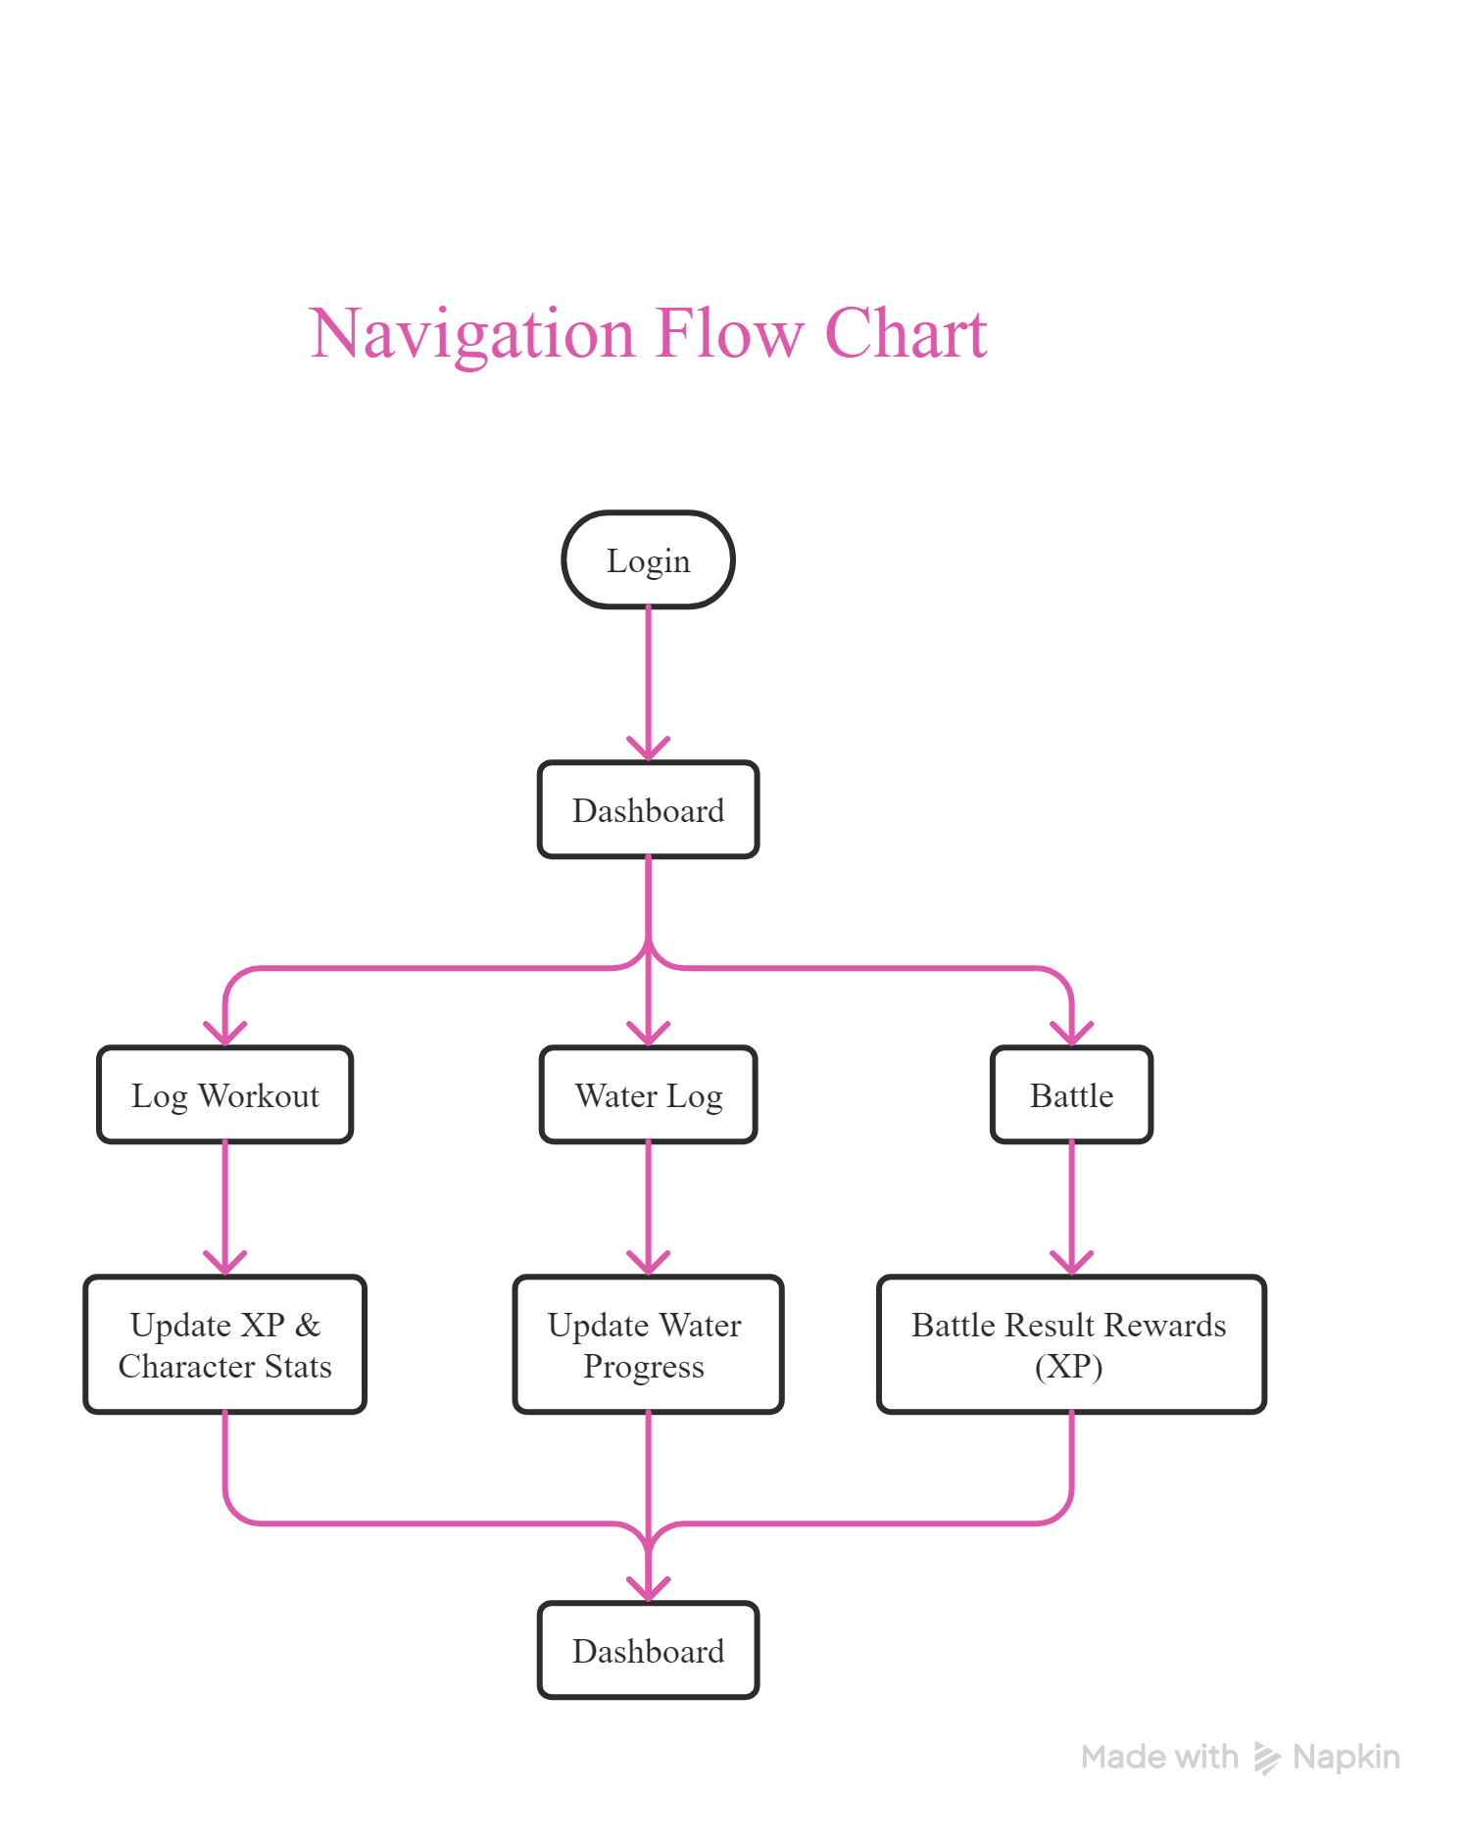
(Explanation
This flow chart shows how users move between screens in the app. A user will log in, check their dashboard, record a workout and then return to the dashboard to see their updated progress.)

Part 4: AI Integration
Feature Name:
- Workout Recommendation System
Problem it solves:
- Many users do not know what workout they should do next so the AI helps guide users by recommending exercises based on what body part they want to focus.
Input (data used):
- Workout history
- Body parts trained
- Hydration history
- Character stats
Output (result generated):
- Suggested workout
- Recommended exercise
Where it appears in UI:
- Dashboard screen
Which module it belongs to:
- Workout Module

(Explanation
The AI helps users choose their next workout. By looking at their workout history and activity, the system can suggest exercises that would make sense for them to do next. This helps the users feel like they are not lost.)

Part 5: System Mapping
Login Screen
> POST /auth/login > Users collection

Register Screen
> POST /auth/register > Users collection

Log Workout Screen
> POST /workout > Workouts collection

Water Tracker Screen
> POST /water > WaterLogs collection

Battle Screen
> POST /battle/start > Battles collection

Dashboard Screen
> GET /dashboard > Workouts + WaterLogs + Characters collections
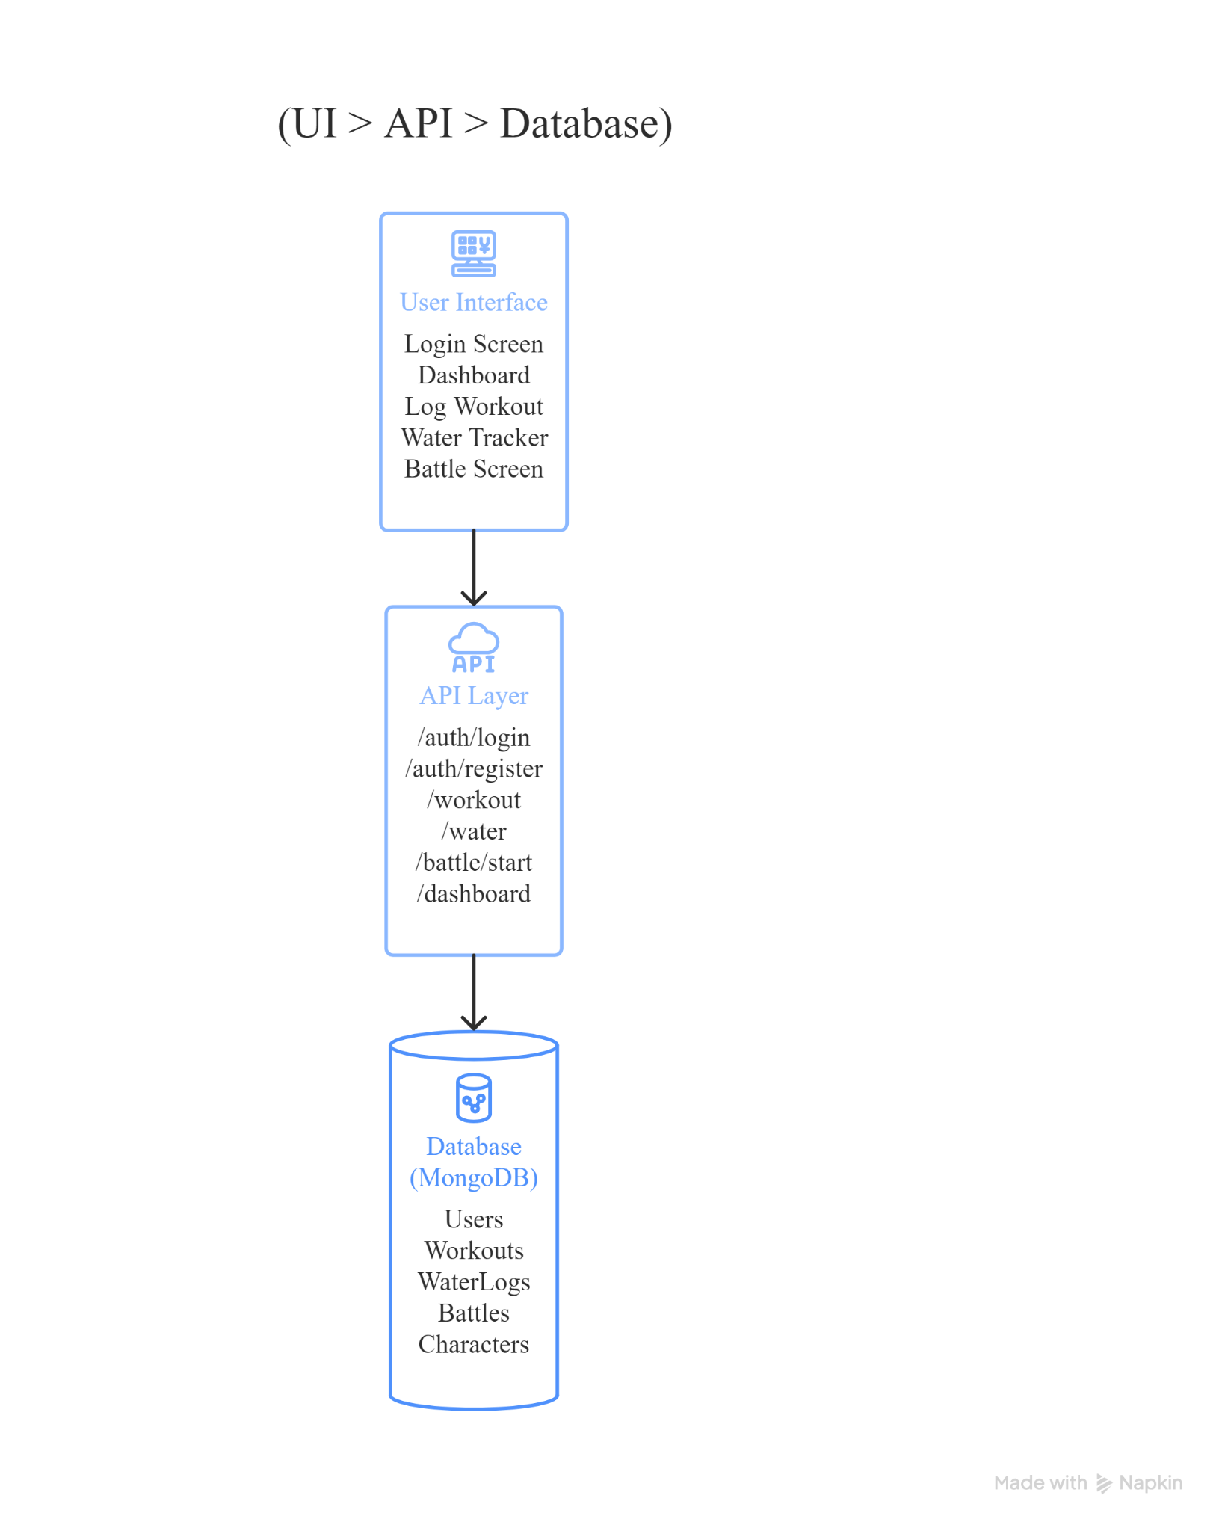
(Explanation
This section explains how the different parts of the system communicate with each other. When a user performs an action on the app, like logging there workout, the interface sends a request to the systems API. The API then stores the information in the database which is MongoDB.

Part 6: Existing System Analysis

Application:
- MyFitnessPal
Key Features:
- Tracks workouts
- Tracks calories and nutrition
- Tracks water intake
- Displays progress charts
Limitations:
- No RPG game features
- No character progression system
- No battle mechanics
- No AI workout suggestions
Comparison with Our System:
- Our system combines fitness with game RPG features. Instead of only tracking workouts users can level up characters and participate in raid battles. Our system is more engaging because it combines fitness tracking with a game system. Instead of only recording workouts and users are rewarded with character progression. This makes the person feel like they are getting something out of their workouts.
New features introduced:
- The main new features are RPG character progression, battle mechanics and AI workout suggestions. These features help users with workouts and also keep them motivated and make the fitness experience more fun.
Why our system is more modern:
- Our system combines fitness with game RPG features and AI recommendations in one application. This makes the app feel more interactive and fun.

(Explanation
I looked at MyFitnessPal as an example of an existing fitness tracking app. It tracks workouts and nutrition but it does not include any game features. Our system is different because it combines fitness with a RPG system that will keep users active and have fun.)

